IOT BASED WEATHER ADAPTIVE STREET LIGHTING SYSTEM

**Abstract**

This project is going to be used to transform lighting from an easy illumination source into a smart infrastructure of the project. It helps in sensing the surroundings and providing the lighting consequently resulting in the economical use of electricity and saving energy. The project helps in controlling the road lights wirelessly in a very centralized manner. The lights may be switched ON and OFF anytime anyplace. Also, the intensity of the light can even be controlled in line with the level of darkness within the encompassing.

**Block diagram**

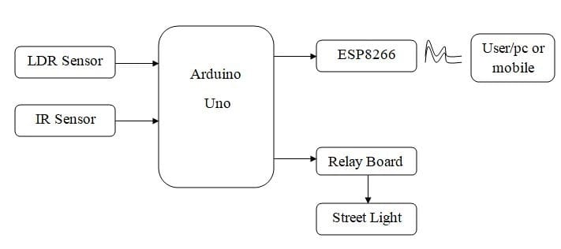

**Software Requirements**

**Arduino IDE**

**Embedded-C**

**Application**

**Exciting**

The street light is one of the huge expenses in a city. The cost spent is huge that all the sodium vapor lamps

Consume more power. The expense spent on the street light can be used for other development of the nation.

Currently a manual system is used where the light will be made to switched ON/OFF. i.e. the light will be made

to switched ON in the evening and switched OFF in the morning. Hence there is a lot of energy wastage between the ON/OFF.

**Proposed System**

This project aims at planning a smart street lighting system for energy saving of street lights. It controls the street lights supported by the detection of vehicles or the other obstacles on the street. We are able to control the lights wirelessly and additionally vary its intensity depending on the darkness level. Whenever the obstacle is detected on the street within the desired time the light can get automatically ON/OFF in line with the obstacle detection.

**Conclusion**

This project “IOT Based Smart Lighting and With Weather Include Street Lights System” may be a worth effective, eco-friendly and thus the safest technique to avoid wasting energy and through this technique, the sunshine standing data is accessed from anytime and anywhere. It clearly tackles the matter the earth is facing lately that’s, saving energy. The project has the scope in varied various applications like for providing lighting in industries, campuses, and parking uncountable massive areas like malls. The project presents more advantages that could overshadow the present limitations. Keeping in view the long run advantages and thus the initial worth would ne’er be an associate issue because the investment repetition time is extraordinarily less.